### CS-571 Building User Interfaces, Fall 2021, Professor Yuhang Zhao

# Javascript *β* (2 Points) Empathy-Driven Redesign Using Component Libraries

[GitHub Classroom Starter Code for JavaScript β](https://classroom.github.com/a/QFtOKQW6)

In this assignment, you will practice design thinking and visual design methods to improve upon Badger Bank. You will complete this assignment in three parts.

In the **first** part, you will practice using the "empathy" method (the think-aloud protocol) that we have discussed in class as a method that will give you the most bang for the buck in terms of understanding user needs, preferences, and behavior. Specifically, in think-aloud, you will (1) identify users who represent your target group of users, (2) identify/develop tasks that represent the functioning of the target system, (3) observe users as they perform the tasks, and (4) analyze your data to develop design insight.

In the **second** part, you will practice the ideation and visual design principles you have learned in class to turn your design insight in the first part into a redesign of the Badger Shop website you have created, expressed in a layout sketch.

Finally, in the **third** part of the assignment, you will implement the design you created in the second part using the Bootstrap component library. This three part assignment will take you through user research to ideation and from sketching to implementation of user-facing elements. Follow the instructions below to complete the assignment.

### **Part 1:** Think-aloud

(0.1 Points) **Step 1. Identify users.** Who uses online shopping? Describe below the characteristics of this user group, identify one person (a roommate, a friend, or a family member) who might be willing to take part in your user research, and ask the person for their interest/availability. (If the person you identified is in this class, it is acceptable to swap roles.)

**Users**: anybody/everyone (however specific to this project it would be badger students/alums or people with connections to UW-Madison). In general, this group would typically be too busy to go to an in-person store or prefers the speed of purchasing items quickly on the website (through searches).

Two people who I asked to take part in my research were my mother and one of my friends who attends UW-Madison. I asked my mother because she often frequents online shopping sites and will have great inputs to give. Furthermore, my friend on campus will be able to provide insights better related to the badger shop application – giving a better understanding on this aspect (however, for the think-aloud, I am using my friend – Kaushal).

(0.1 Points) **Step 2. Develop tasks.** Study the new Badger Shop application, JavaScript **β**, to develop a set of tasks that users might perform with the system. Rank your list in terms of importance (simultaneously considering impact, frequency, prevalence) and identify the top three tasks. Describe each task in 1–2 sentences in a way that your users can understand.

**Note:** Your tasks can focus on the general visual and click-through navigation of the site and interact with personal information in a very limited sense.

1. **Download their Order History**: clicking on the button labelled “Download Order History,” users are very likely to download their order history for past orders. They would frequent this to remember their regular orders and/or to keep track of their expenses.
2. **Go back to the top of the page**: Using the link labelled “Back to top” at the bottom of the page, users be taken to the top of the BadgerShop page. However, I do not see it as an important aspect as most users would still use their mouse to scroll to the top (unless they have large order histories/subscriptions that will take time to scroll to the top).
3. **Download Subscription Invoice**: Another key feature would be using the button labelled “Download Subscription Invoice” so users can view a pdf of their invoice subscriptions. This would only be used once a month when they are billed (maybe an extra time in the middle for users to remember what their subscriptions are).

(0.2 Points) **Step 3. Perform think-aloud.** Hold a think-aloud session with your representative user (e.g., over Zoom using screen sharing) *on* ***a real shopping website*** (NOT the Badger Shop interface). First describe to your user how the think-aloud will work (refer to the reading and class notes), describe the tasks one at a time (answer any questions you might have), and ask them to perform each task while they say out loud what they are thinking.

**Pro tip:** If you see your user performing the task but not speaking, probe them by asking what they are thinking or reminding them that they should be describing.

As you observe your user performing the tasks, take notes (using the other sheet) of important actions, problems they encounter, confusions they might voice, and so on. For anything that stands out, after each task, ask your user why they did that or said that. Your observations and notes will form your data. Include your data below.

**Note:** If your tasks involve entering or reviewing personal information, you can ask your user to stop screen sharing while they perform these actions in order to preserve their privacy.

I made Kaushal do the tasks on the Nike website.

**Task 1:** Look for Soccer cleats on the site.

He could not find a “shoes” section.

He went to the magnifying glass (search bar) and looked it up.

**Task 2:** Sort/Filter them by your size and add your favorite pair to the cart.

He clicked on the filter button but was stuck for a small bit as he couldn’t find the sizes.

After he couldn’t find the size filter, he took the longer way to finding the cleats (repeating step 1) by going to the “Men” section and then clicking “Shoes”.

He went to filter again, and successfully found the size he wanted.

He chose the “Soccer Shoes” link, chose a pair of cleats and added them to his bag with ease.

He was a bit frustrated as it asked him to select his size again before adding to his bag.

Another note is that he was a bit annoyed of not being able to filter by size from a direct search.

**Task 3:** Now look for a discounted item (at least 20% off) and add it to your cart

He was able to find the “sale” section with ease, but the page did not show any discounted items.

After a bit of confusion and scrolling, he went back to the top of the page to the filter section, where he found a filter for discounted products (and selected “20% and above).

However, he was still confused as it still didn’t mention the discounts. After more confusion, he expanded the web page to full screen where the items were finally listed with the discounts.

He was quite annoyed again as he put out a small rant on how it should still show the discounts on the reduced size screen.

**Task 4:** Go to your cart and simulate checkout process.

He found it easy to find the cart as it had the number “2” on the briefcase. However, he did state that the icon was misleading and he would not have guessed that to be the checkout/bag icon.

He was glad to have a “guest checkout” option as he did not have an account and it was fairly straightforward process (he added fake payment details for the sake of this session).

(0.2 Points) **Step 4. Create insight.** In your data (e.g., notes), highlight where you saw significant breakdowns in functioning, need for better functioning, or user preferences that would require an alternative design. Make a list of your findings as design recommendations.

1. It was inconvenient to not be able to filter by size when you use the search bar.
2. Even though the size filter was applied, it was tedious to have to select the size again when adding shoes to the bag.
3. The size of the screen should not affect the ability to show discount values. It should just be made as part of the product box (within the border for each item).
4. Using a briefcase is a bit misleading when trying to find the cart/bag. The icon should be made so users from other shopping sites would be able to find it with ease (a cart would be more general).

### **Part 2:** Design

(0.4 Points) **Step 1. Visual Design.** Next, using knowledge of shopping operations from the think-aloud, you will redesign JavaScript **β** with the goal of improving its visual design. First consider what elements you must place on the canvas. All elements should have a function. If the original design included elements with no function or use, you can exclude them in your redesign. Next, consider the design principles, and ask yourself, “how can I direct user attention appropriately,” “do I need to create contrast between elements,” “how do I achieve unity,” and so on. You will need to go back and forth between the elements and principles. For example, you must determine what user attention should be directed to, such as a product photo, a button, or a paragraph of text, in order to place the focal point to it. Similarly, you should think about the composition of elements to create an appropriate level of balance on the page. Your redesign should be in the form of a digitally- or hand-drawn wireframe with annotations that justify the use of the elements and principles.

For all 3 pages, will have the Logo centered on the top, and Contact Details centered at the bottom. Furthermore, I have 3 buttons/links centered below my Logo that will represent which webpage/section of the site we will be able to see. I also have a logout button aligned to the right of each page (as expected on any shopping website).

* All of these items are centered to give a sense of balance to the webpage. This applies to all webpages/sections and also ensures that there is no misbalance of white space on either side of the page.
* The logo on top will direct the user’s direction there as it stands out from the design from the rest of the pages (it is the only image on any page), hence it will then allow the user to work downwards from there (rhythm/movement).
* The buttons/links below the logo gives the shop a unique functionality with different sections split into their own links/pages. It makes the site a lot cleaner with no unrelated information getting mixed with each other.
* Putting the contact details at the bottom is consistent with what one would see in most shopping websites. This will also match with most user’s preferences as they expect to see this information at the bottom.
* The use of rectangle/square sections throughout the pages give a sense of uniformity and makes the page look clean and consistent. It also makes it easier to divide and read separate section/information easily.

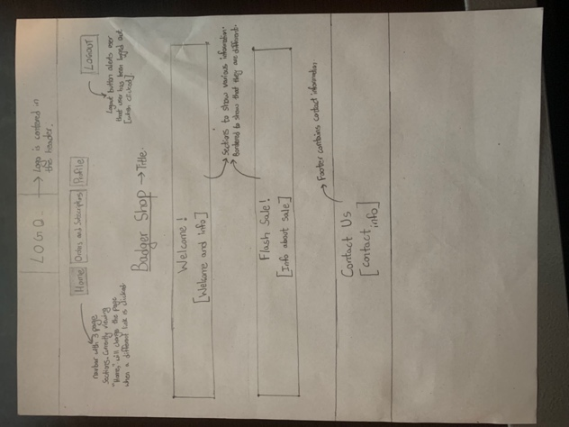

This is the first/main page of my design. Its primary function is to display the general details about the site and serve mainly as a welcome page. This webpage will have 2 sections – one to welcome the user and give a description of Badger Shop and the other will talk about the flash sale and more details about it.

* Since this page has 2 sections, it will be clear and concise.
* “Welcome” and “Flash Sale!” will be larger and bold compared to the rest to direct user’s attention to the headers and then to their associated descriptions.

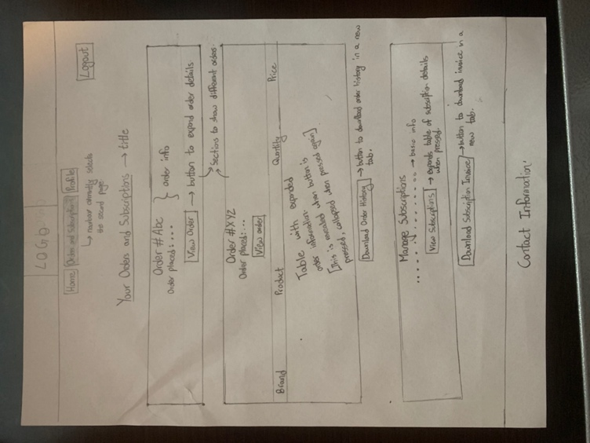

My second page/section is primarily to display the user’s order history and subscriptions. This webpage is divided into many more sections – one for each previous order that the user has places (each that has a button to view/hide the individual order). There is a button below all the orders that will allow the user to download their order history in a new tab. The next part is the user’s subscriptions – that will be shown/hidden with the press of a button. There is also a button at the end of this that will allow the user to download their subscription invoice (also in a new tab).

* The headers for this page will also be bold and larger font – giving emphasis to them and directing the user’s direction to them before heading to their subsections below.
* The use of buttons adds unique functionality. The placement of buttons at the bottom of their sections, hiding and showing their respective information, creates a uniform pattern and helps to achieve unity with each section in the webpage.

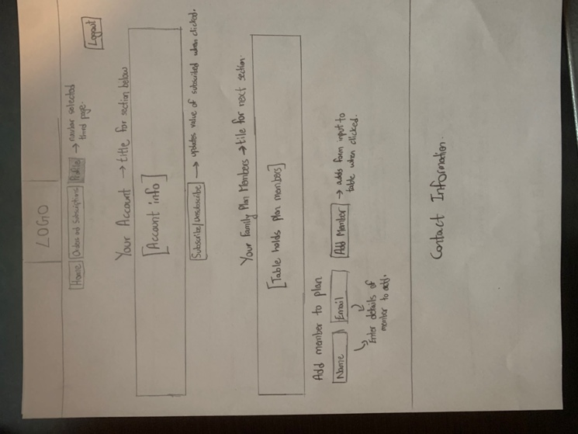

The third and last page/section of my redesign is to display the details of the user’s account and family plan. This webpage presents the user’s account details – with the same subscribe/unsubscribe button from the original design. The next section will have the user’s family plan members listed (which can be viewed with the press of a button). Below, there is a form to enter member details and a button next to it to append this member to the family plan.

* As with all the previous pages, the larger headers make them stand out and directs the user’s direction there before moving on to read the subsections.
* The use of buttons here serves a similar purpose as the previous page. Creating a uniform pattern and helping to achieve unity with their respective sections.

I have also removed the “Back to top” link and functionality as separating the document into 3 different pages/sections reduces the need to scroll. Furthermore, the “Add a member” button functionality was changed to a form input and submit button.

(0.2 Points) **Step 2. Specify color and type choices.** Finally, determine what color palette your redesign should follow. How many colors/shades will you use? Why will you use these colors? Keep design principles in mind when you are choosing colors. For example, using contrasting colors, you can create contrast and manage user attention. Additionally, determine what category of typeface and what font you will use, whether or not you will use multiple fonts on the page, and how you will parameterize each font. You may review the fonts in your computer’s fonts folder (on Windows, go to “My Computer > Control Panel > Fonts” and select “View > Details;” on the Mac use the Font Book app) or the [Google Fonts collection](https://fonts.google.com) to give you ideas and get familiar with available typefaces.

**Color:** The color palette I would use is monochromatic (focusing specifically around the UW colors: Red and its shades, White, and Black). I choose these because it will be more representative and clearer that it is a UW-related website. Furthermore, it will make the website a lot more readable and welcoming (as we have seen with other UW websites with similar color schemes).

**Type:** The font types I will utilize will be Helvetica and Arial (Sans-Serif). I chose this because it is very readable across various text sizes and since it is one of the cleaner font types, it will have the same effect on the site.

### **Part 3:** Implementation

(0.2 Points) **Step 1. Inspect component library elements.** In this step, you will inspect the [Bootstrap](https://getbootstrap.com/docs/4.5/getting-started/introduction/) component library to see how you can realize the layout, visual-element, and color/type choices you have made in the previous part using the component library. You are not expected to change the library components to exactly match your design choices, but to identify which component elements might best meet your design goals. Below, copy the design and the choices you generated in Part 2 and annotate them to describe which components from the library you will use to accomplish your design goals.

* **Nav:** This will be used for the links on the top of the page to show each section of the page.
* **Buttons:** They will be used to help with the buttons on the pages and perform their unique tasks (show/hide tables).
* **Form:** When a user wants to enter a new family member, they will enter their information with this and add it to their table with the help of a button.
* **Tab pane (similar for nav usage):** This will allow us to separate each section and show specific information regarding the page we are on.
* **Collapse:** this will be used to expand and collapse the tables for the “orders and subscriptions” page.

(0.6 Points) **Step 2. Implement your redesign.** The last step of this part will involve implementing the layout and components you had identified in the previous step. You will include Bootstrap in your project and use it to implement your design. You do not have to implement new *functionality*; focus on implementing your *design*.

Your deliverable will be a completed version of this document, attached to the canvas assignment as a PDF, and the GitHub Classroom repository name and latest commit hash.

